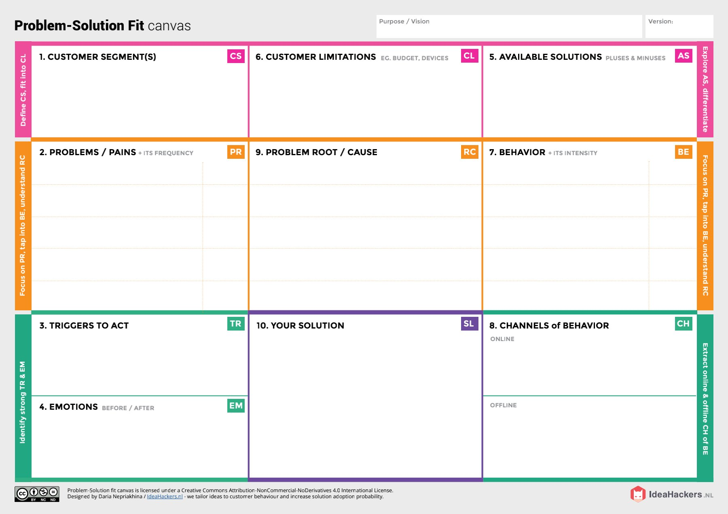

* **Asking suggestions from surrounding peoples and implementing the recent technologies**
* **Searching an alternative solution from an already existing solution.**
* **Hearing about innovative technologies and effective solutions**.
* **Seeing others having better results while following this correct data analyse make better option while compared to other solutions in avaition.**
* **Lack of knowledge among people regarding the proper amount of data analysis.**
* **Many suggestions for a single change make it hard to concentrate on following a particular routine**
* **Using different platforms /social media to describe uses of the avaition industry and how it works as a great tool for airlines.**
* **Gives awareness among people about the types of features intake and how the platform is useful for various people who is interested in travel on world.**
* **improper collection of analytical data injured avaition related issues.**
* **A lot of issues boil down to there simply being a lack of workforce**
* **There to be an working hard for the upcoming future avaition.**
* **The clients who are collecting proper data of airlines.**
* **Allocate the design to make it property.**

**PNT2022TMID37057**

**Airlines Data Analytics For Avaition Industry.**

**Project Title:**

**Team ID:**

**Project Design Phase-I** - **Solution Fit Template**

* **Artificial intelligence monitors customer traffic and engagement and learns from insights to promote self-service and sales systems.**
* **The Airlines gets all the required data like specification and the user and according to the industrial clients and their desired body shapes. it creates a perfect plan that will make them reach goals in an efficient way.**
* **It can provide society using all data of the different airlines must required for Avaition industry.**
* **It makes sure the right amount of conclusions are taken in at the right interval of time .**
* **People are unaware of what decission to take and the right amount.**
* **Step by step instructions provided by the professional industrial managers.**
* **Limited supervision.**
* **Limited financial constraints.**
* **Limited information on specified airlines.**